
Important
Legal Notice
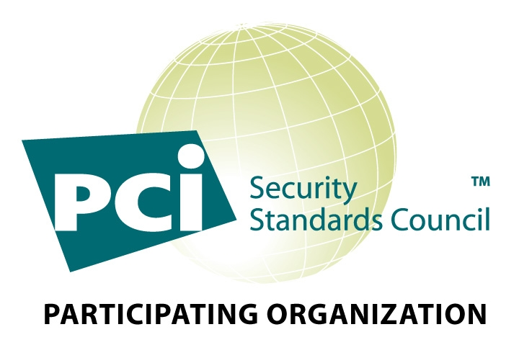

December 29, 2008

Dear Valued MICROS Customer:

MICROS has sent many letters over the past years in an ongoing effort to educate and remind its customers how imperative it is to comply with all of the Payment Card Industry, (PCI), security and legal requirements. For those merchants that still have not upgraded to one of the currently available versions of the MICROS PMS/POS software that have been validated as compliant with either the Visa Payment Application Best Practices, (PABP), or the Payment Card Industry Payment Application Data Security Standard, (PCI PA-DSS), you are in violation of both: (i) the formal standards published by the Payment Card Industry, (the “PCI”); and (ii) the Federal Statute known as The Fair and Accurate Credit Transaction’s Act of 2003. Accordingly, you risk being subject to significant penalties, fines, and legal sanctions. The fines that are being levied are not trivial and could have serious financial impact to your business. Legal liability may arise as well. Neither MICROS nor your service provider is liable for any damages you incur in connection with using non-compliant products.

As your technology provider, we continue to take this initiative very seriously. When the new PCI guidelines were announced, which prohibited the storing of track data and the printing of credit card and expiration information on customer receipts, among other things, MICROS implemented changes to all of its software applications. These enhanced MICROS products have been made available to all MICROS customers since March 2004, subject to standard upgrade charges. Compliancy status of all of our products may be found at www.micros.com/Products/VISACISP.

As you know, the PCI now proactively administers fines to member banks that have merchants that are storing full magnetic stripe data. These fines could be imposed at any time, and could be very large. If you are identified as a merchant using a non-compliant product, there is an increased likelihood that your bank may be fined and will pass the fine to you for non-compliance. There is also a significant likelihood you could be printing information on credit card receipts that is in violation of Federal law.

If you have not already done so, it is imperative that you immediately upgrade your MICROS PMS/POS systems to a version that is certified as compliant with either the Visa PABP or PCI PA-DSS. MICROS also recommends that its customers take steps to ensure that they are operating in compliance with the Payment Card Industry Data Security Standard, (PCI-DSS). For more information on this, please refer to the PCI web site at the following URL: https://www.pcisecuritystandards.org/

We urge you once again to contact your local MICROS office or account manager to determine if you need to upgrade the MICROS software you are utilizing.

Best Regards,

MICROS Systems, Inc.

